JavaScript function

Write the JavaScript code to implements the following using function

* the addition , subtraction ,multiplication and division of two number

1. that calls it self
2. that call by button (onclick function)
3. That call by JavaScript code

* Write program that implements the following formula (y=mx+c) then when you input the m value and c value will give you expression. ex(y=5x+6)
* Write program to perform the following

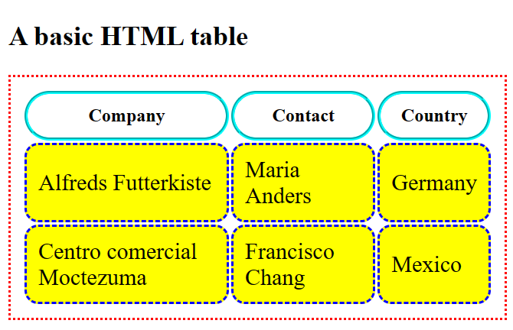

* Write a program that will perform the following declaration const number =[1,2,3,4,5];

Then the function must return double of it number *2;

Output must be [2, 4, 6, 8, and 10]

* Create function that will repeated the statement using only one function , this function will help to produce more then one statement using parameter declared ex function myfun(my)

{

Code will run here

}

Const name 1= myfun( any word);

Const name 2=myfun(any word);

So you can either use (document, alert or console) to print and out put

The out putt will be example HELLO, REHEMA

HELLO, AWATIF

* Please don’t use **chartgpt,poe or any artificial intelligence AI** to do this use your mind and either google , or w3school allowed
* **Note use JavaScript ,css,html to do this**